DIY Digital Camera – Pinhole Cameras
Concept Example: https://orbides.org/photobot.php?lng=eng
A pinhole camera is an old concept. With a small enough hole an image can be projected on a plane opposite to it.

The optimal size of the pinhole is calculated by this formula:
Where f is the distance from the hole to the plane, lambda is the wavelength, and d is the pinhole diameter.

The image, projected from a pinhole will be quite faint. To read it off, we need a good sensor. Normally, that would be a job of a CCD matrix or some such, but that's not our way. Photodiodes are made in a variety of wavelengths and are normally sensitive enough for the task. With only one photodiode it has to be moved across the image plane.

Initial Design –
- Begin with a Box, Make a pinhole mount in it with the above formula.
- Inside the box, place a cartesian robot inside with a sensor.
- This will result in a Camera

Sensor:
The sensor for step 2, must be capable of seeing the shades in the faint light of pinhole's projection, therefore a photodiode should be good enough.
It's a simple semiconductor that converts light or similar waves into electricity. Solar panels are big photodiodes, for example:

- The smaller the photodiode is, the higher the resolution is.
- The bigger the photodiode is, the lower the noise is.

7.5 mm^2 sensor:


1 mm^2 sensor:


When Investigating photodiodes –
Silicon ones, 300nm-1000nm:

- Green photodiode, BPW21r - too much capacitance
- NIR photodiode, BPW41n – Could fit the necessary parameters

All visible light photodiode:

- BPW34, very sensitive - easily covered to reduce size

Getting InGaAs or InAs for lower bands isn’t easy:
- They’re considered dual use devices and are under export control for international shipping.
- InAs photodiode, made by Ioffe institute in St. Petersburg. Peak sensitivity at 3400nm.

Amplifier
But how do you read a value off it?

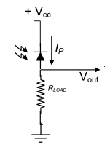

With such a set up you will indeed be able to tell night from day, but not much else.
More practical solution would be a transimpedance amplifier.

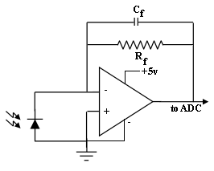
This circuit would convert the photocurrent from the diode into voltage for Arduino or other ADC to read. And by using it with 50M Ohm resistor you would indeed be able to read off a faint image in the direct sunlight

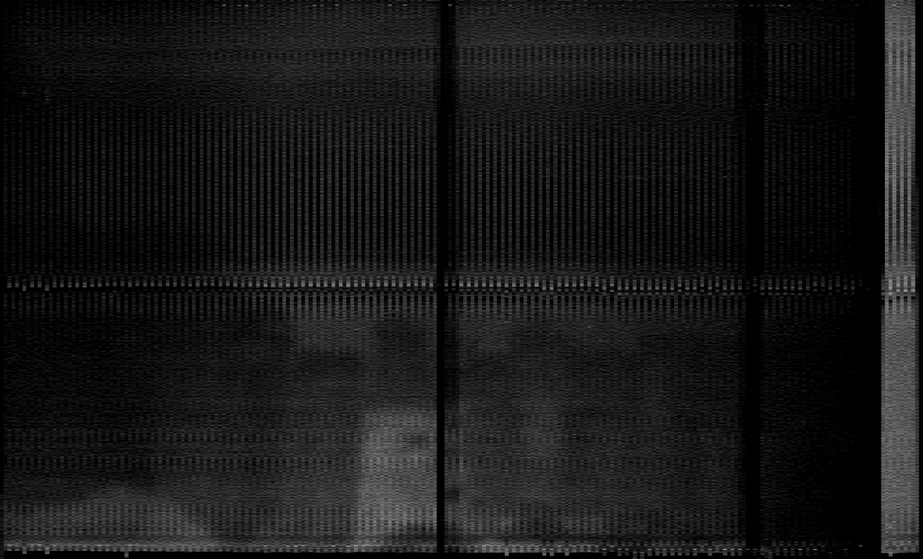

To get better sensitivity it will take bigger resistors:

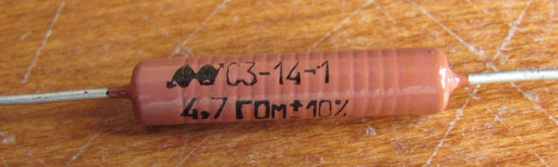
But giga ohm resistors mean pico Ampere level currents being amplified. And that opens a whole can of worms.

Mechanics:
The box
The box should be lightproof. Otherwise you'll see ambient light from the holes instead of pictures.



It's a good idea to wrap the box into grounded tin foil. If you don't isolate outside EMI, all you'll see in civilized areas is mains hum, especially with pA-level amplification:

The Robot
Use a two-axis moving platform. One axis has to be fast (or you'll have to be patient) and will hold the sensor on it. The other axis can be as slow as comfortable and will move the fast axis.
The Power
Need a battery that can handle the load with time to spare. If the power start to drop, you will get changes and degradation across the image.

- 8 AA batteries, full on the right, scans to the left as they die
- A UPS lead-acid battery supplies a steady current all the time

Noise Handling
Making the sensor head:

You need serious amplification to get images out of a pinhole-focused light spread over a good portion of a square meter. In fact, it's sub-picoampere current sensing for the pinhole, and nanoamperes if you put a lens in it. So, if you put the amplifier on the side, and lead a wire to the PD on the caret.
There are two parts to noise generated.
- The mains hum and other external EMF.
- The stepper motors noise and other internal EMF.

First can be solved by wrapping the box into tin foil and connecting that to the common ground inside. The second would require additional shielding at the scan head itself and some careful design of the scan system. Therefore with the amp shielded on its own, the noise would go down to almost nothing.

So this concept would provide the results needed but global situation makes the acquisition of parts difficult. Further detail will be investigated and written via the project report

Second Possible Design Option
Build a single-pixel scanning camera with an RGB sensor

Potential sensor - TCS34725 from Adafruit
It can detect a single colour.
- To reason then, that if you were to aim this sensor at a multitude of points and record the resulting data, you could have a one-pixel camera.

The TCS34725 is a colour light-to-digital converter sensor from Adafruit. It is capable of detecting the colour of ambient light or light being reflected off of objects, and providing the red, green, and blue (RGB) values of that light as well as its infrared (IR) intensity. This information can be used to detect the colour of an object, determine ambient light levels, or even perform colour correction. The TCS34725 sensor communicates with the host microcontroller over I2C, making it easy to interface with a variety of microcontroller platforms such as Arduino, Raspberry Pi, and others.

Sensors like the TCS34725 from Adafruit can detect a single colour. It stands to reason then, that if you were to aim this sensor at a multitude of points and record the resulting data, you could have a one-pixel camera. Alternatively a photoresistor can be used in place of the RGB sensor for black and white photos!

The device would look like something akin to some sort of auto-turret and directs the sensor in a square spiral for image acquisition. The resulting pictures would certainly be low-res, but good enough to pick out recognizable forms with a little imagination.

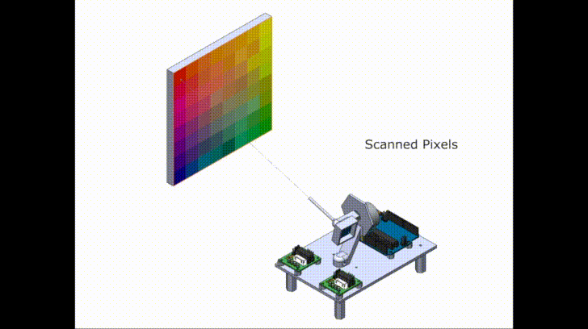
1x Arduino Uno
Arduino Uno is a microcontroller board based on the ATmega328P (datasheet). It is a part of the Arduino platform and one of the most popular boards in the Arduino community. The Arduino Uno has 14 digital input/output pins (of which 6 can be used as PWM outputs), 6 analog inputs, a 16 MHz quartz crystal, a USB connection, and a power jack. The board can be programmed using the Arduino Integrated Development Environment (IDE), which is a cross-platform application that runs on Windows, macOS, and Linux. The Arduino Uno is a simple and versatile board that can be used for a wide range of projects, including controlling LEDs, reading sensors, and communicating with other devices over USB or other communication protocols such as I2C and SPI.

x2 BYJ-48 Stepper motor with drivers
BYJ-48 stepper motors are small, bipolar stepper motors that are commonly used in a variety of small robotics and automation projects. The "BYJ-48" designation refers to the specific model of the motor and its 48-step per revolution, which provides a relatively high resolution of movement.

Stepper motors are different from traditional DC motors in that they move in steps, rather than smoothly, and can be accurately controlled to move a specific number of steps. This makes them ideal for applications where precise control of position is important.

The drivers you mentioned are used to control the BYJ-48 stepper motors. A stepper motor driver takes the step and direction signals from the microcontroller and converts them into the appropriate electrical signals to drive the motor. Some drivers also include additional features such as current control and micro stepping, which can be used to fine-tune the performance of the motor.

Having two BYJ-48 stepper motors with drivers will give you the ability to control two separate axes of motion in your project, which can be useful for things like robots, 3D printers, or other applications where precise, coordinated motion is needed.

x1 3mm OD aluminium tube
A 3mm outside diameter (OD) aluminium tube is a small cylindrical shaped component made from aluminium. Aluminium is a lightweight and strong metal that is commonly used in a wide range of applications due to its low cost, good conductivity, and resistance to corrosion.
The use of a 3mm OD aluminium tube will depend on the specific requirements of your project. For example, it could be used as a structural component in a mechanical assembly, as a conduit for electrical wires, or as a support for other components. The tube's size, strength, and corrosion resistance make it a versatile component that can be used in a wide range of applications. Additionally, the tube's small size and lightweight makes it ideal for use in projects where space and weight constraints are a concern.

x20 M3x6mm fasteners
M3x6mm fasteners are small screws with a metric thread size of 3mm and a length of 6mm. The "M" in "M3" stands for "metric," and the "3" indicates the diameter of the screw thread in millimeters. The "x6mm" indicates the length of the screw, in this case 6mm. The "M3x6mm" designation is commonly used in the fastener industry to describe the size and specifications of screws and other threaded components.
These fasteners are commonly used to secure parts together, such as attaching a component to a printed circuit board (PCB) or fixing two pieces of metal or plastic together. They are also commonly used in electronics and hobby projects due to their small size and versatility. The M3 size is one of the most common screw sizes used in hobby and small electronic projects, and the 6mm length provides a good balance between holding power and clearance.
Having 20 M3x6mm fasteners at your disposal gives you the ability to secure multiple components or parts together as needed in your project. These fasteners can be used over and over again, making them a convenient and cost-effective component to have on hand.

Thingiverse – Used to connect parts in more organise fashion. Makes the design look much nicer

Thingiverse is an online community and platform for sharing and discovering 3D design files. It was created as a way for makers, hobbyists, and DIY enthusiasts to share and find 3D designs for their projects and has since become one of the largest repositories of 3D designs on the web. Users on Thingiverse can upload their own 3D designs, and others can download and use those designs for free. The designs on Thingiverse cover a wide range of categories, including toys, jewellery, replacement parts, and even furniture. In addition to being a library of designs, Thingiverse is also a community of makers, where users can connect and share ideas, provide feedback, and collaborate on projects.
Thingiverse is a great resource for anyone looking for 3D designs for their projects, or for anyone looking to share their own designs and connect with others in the maker community. Whether you are a seasoned maker or just getting started, Thingiverse is a valuable resource that can help you find the design files you need and connect with others who share your interests.

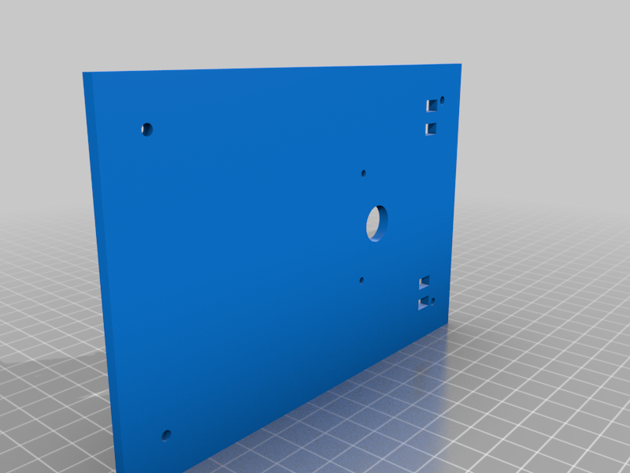
X1 – Table
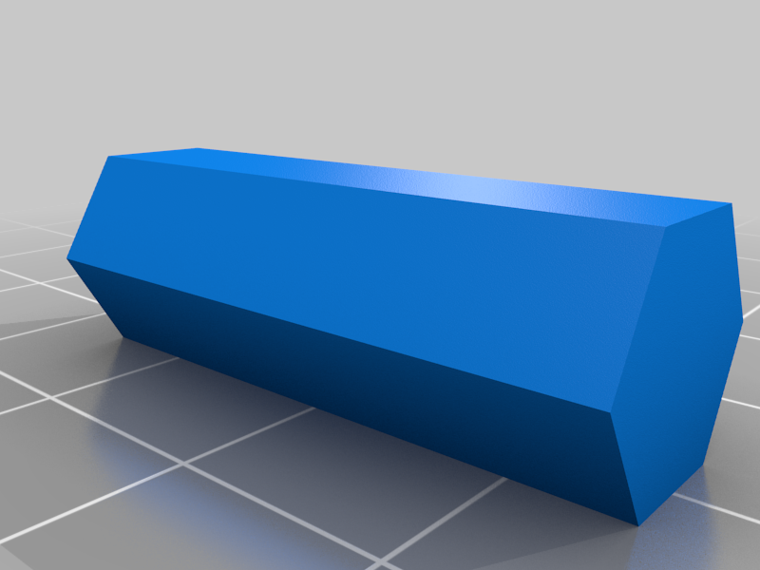
X4 - Legs
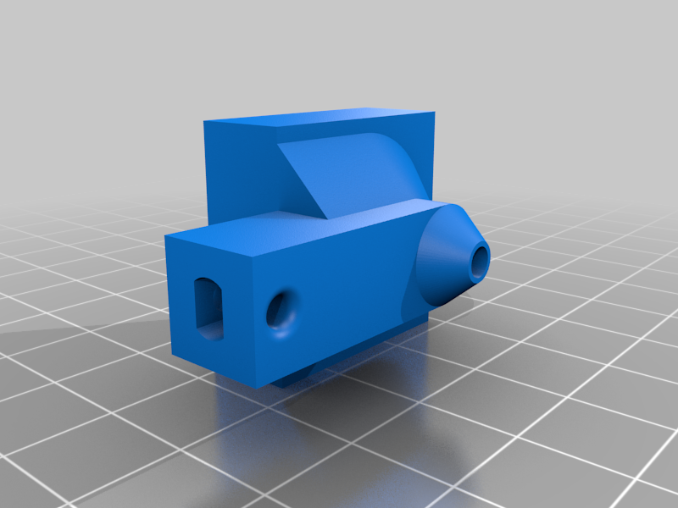
X1 – Camera Holder

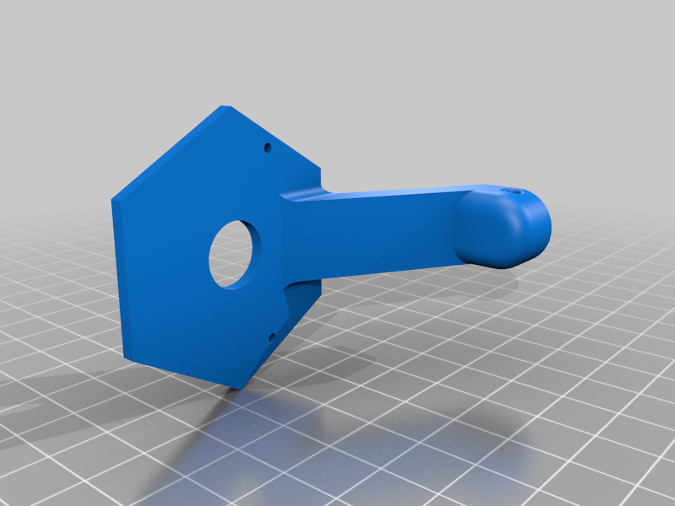
X1 – Tabletop

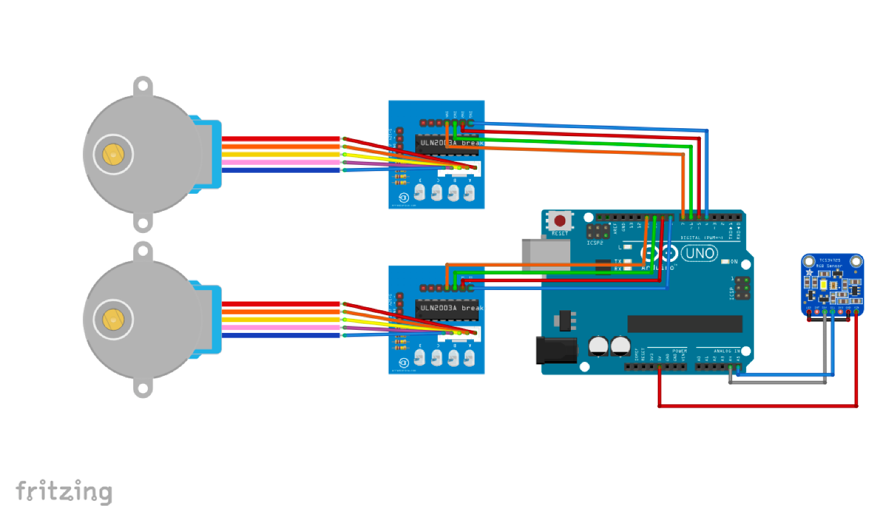

Design Purposes
Make a Cheap cardboard box to make it look like an old school Camera

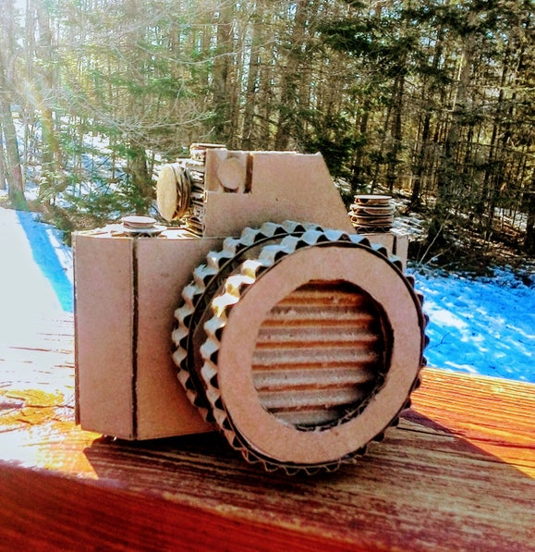
Design 1

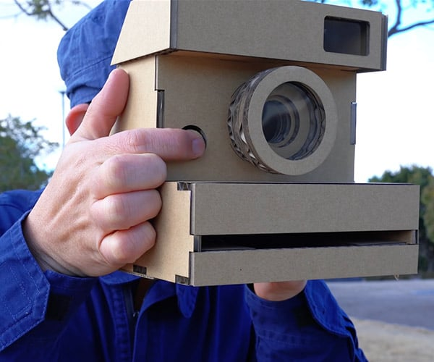
Design 2

Ordering Parts – Where to Order

1x Arduino Uno – Amazon, https://www.cricklewoodelectronics.com/
x2 BYJ-48 Stepper motor with drivers – Amazon, https://www.cricklewoodelectronics.com/
x1 3mm OD aluminium tube – Amazon, https://www.aluminium-online.co.uk/product/30mm-x-3mm-aluminium-round-tube/?gclid=CjwKCAiA3KefBhByEiwAi2LDHGOdNHyLFl-IGEVJbk0vyscwDS5BW5jykwZV_fwugKzSbrTPh9ExqBoCafoQAvD_BwE
x20 M3x6mm fasteners – Amazon
Cardboard Sheets to Build – Amazon
3D Printing – Amazon, Google & https://xometry.uk/3d-printing/?utm_source=google&utm_medium=cpc&utm_campaign=10330657645&utm_content=605441056773&utm_term=3d%20printing&gclid=CjwKCAiA3KefBhByEiwAi2LDHHMskmPQY4ggJPAEhGpTeQNcthRagmpT7IKJsZY7lvzp1xsr9ZiGuBoCZPMQAvD_BwE

